Using System Archetypes to Inform Implementation and Sustainability of a Restaurant Intervention for Healthier Foods to Improve Healthy Food Access and Consumption
Healthy food interventions in restaurants are increasingly used to improve dietary environments in low-income neighborhoods. However, many interventions produce short-term improvements that decline once program support ends. Understanding the dynamic mechanisms that determine whether healthy food adoption becomes self-sustaining therefore is an important challenge for intervention design. System dynamics models are well suited to this problem because they explicitly represent feedback relationships between organizational decision-makers and the populations they serve (1).
This study develops a system dynamics model based on the NIH-funded FRESH (Focus on Restaurant Engagement to Strengthen Health) intervention trial (2), which aims to increase healthy food (HF) offerings in independent restaurants. The model focuses on the implementation process, explicitly representing the feedback relationships among restaurant owners, customers, and the neighborhood community. Three key stocks are represented: restaurant owner engagement, HF menu items offered by restaurants, and customer interest in healthy foods (Figure S1 in the supplement).
Problem Statement. We seek to identify the dynamic conditions under which reinforcing feedback between restaurant adoption of healthy food (HF) and customer demand becomes strong enough for healthy food offerings to transition from intervention-dependent change to self-sustaining system behavior.
Current Approach
We use system archetypes to analyze the feedback structure of the intervention and identify leverage points in the implementation design. Several classic archetypes (3,4) appear in the FRESH system.
- Limits to Growth, in which reinforcing growth in HF adoption is constrained by restaurant operational capacity. The intervention addresses this constraint by helping restaurants select feasible HF menu items, redesign menus to highlight healthy options, and align preparation requirements with existing kitchen workflows.
- Shifting the Burden, in which short-term demand incentives such as monetary subsidies can temporarily increase restaurant healthy food availability and customer purchases, but do not address structural barriers to adoption. Instead, the FRESH intervention focuses on restaurant capacity, visibility of healthy options, and community awareness.
- Eroding Goals, in which implementation efforts may weaken when progress is slow. Regular visits by interventionalists help maintain intervention goals and provide ongoing technical assistance to restaurant owners during the rollout.
- Success to the Successful, where restaurants that successfully introduce HF offerings attract more customers and continue expanding their HF menus. The intervention attempts to diffuse these successes across participating restaurants through social media promotion, neighborhood engagement, and increased visibility of participating restaurants. One proposed mechanism is a dashboard that shows each participating restaurant its own progress relative to the group average, strengthening peer visibility and motivation.
Together, these archetypes describe the feedback structure through which the intervention operates, providing a conceptual framework for the quantitative analysis that follows
Application to a Real-World Case Study
The model was implemented in both Vensim PLE and Python. The Vensim stock-and-flow diagram helps illustrate the archetypal feedback structure (Figure S1), while the Python implementation was used to explore system behavior across the parameter space. Parameter sweeps reveal tipping points (5) separating two regimes (6): intervention-dependent adoption, in which HF offerings decline after the intervention ends, and self-sustaining adoption, in which restaurant owners maintain HF offerings without continued intervention support (Figure S2). Example simulation trajectories illustrating both of these regimes are shown in Figure S3.
Initial Results. Early simulations suggest that the sustainability of HF adoption emerges from the strength of feedback between customer interest and restaurant owner engagement. When this feedback is weak, healthy food offerings increase during the implementation phase but decline after the intervention ends. When the reinforcing loop between customer demand and restaurant adoption becomes sufficiently strong, the system transitions to a stable equilibrium in which HF offerings persist. Parameter exploration also highlights the importance of customer responsiveness to menu changes and restaurant responsiveness to customer demand signals.
These findings suggest that system dynamics modeling can help identify leverage points for strengthening intervention sustainability. In particular, the model highlights the importance of strengthening reinforcing feedback from customers to restaurant owners, a pathway that directly addresses the Shifting the Burden and Success to the Successful archetypes. Some options for operationalizing these leverage points beyond improved sales of HF include dashboard deployment, customer engagement activities, and community promotions.
Questions for Discussion and Next Steps
Because the implementation of the FRESH intervention is ongoing, we seek input from the system dynamics community on several aspects of our analysis approach. We are interested in:
- Methods for identifying tipping points and sustainability thresholds in implementation-focused system dynamics models;
- Approaches for integrating system archetypes more explicitly into intervention design;
- Strategies for representing behavioral feedback between organizations and communities within system dynamics models.
- Units for representing the stocks in our model.
Parallel to these discussions, our next steps are to refine the parameterization of the model using data from the FRESH intervention and to conduct scenario analysis exploring alternative implementation strategies. The model and associated analysis tools are available through both Vensim and Python implementations (7), including an interactive Streamlit application for exploring system behavior across parameter combinations (8).
Ultimately, this work aims to demonstrate how system dynamics and archetype analysis can support the design of public health interventions that are not only effective during implementation but also capable of sustaining their impact over time.
Keywords: Access to healthy food; sustainable practices; Implementation Science; system archetypes; tipping points
References
- Hovmand, PS (2014). Community Based System Dynamics. Springer
- Colón-Ramos U, Lewis EC, Tucker AC, Poirier L, Pathiravasan CH, Estradé M, Igusa T, Wolfson JA, Mui Y, Vélez-Burgess V, Thomas AE, Hua, S, Cheskin, LJ, Trujillo, AJ, Oladimeji, AT, Williamson, S, Romero, R, Hernández, PS, & Gittelsohn, J. Design of the Focus on Restaurant Engagement to Strengthen Health (FRESH) study: leveraging systems science to work with independently-owned restaurants to increase access to and promotion of healthful foods. Frontiers in public health. 2025 Jan 7;12:1427792.
- Senge, PM (1990). The Fifth Discipline: The Art and Practice of the Learning Organization. Doubleday.
- Wolstenholme EF. Towards the definition and use of a core set of archetypal structures in system dynamics. System Dynamics Review. 2003 Mar;19(1):7-26.
- Farahbakhsh I, Bauch CT, Anand M. Tipping points in coupled human–environment system models: a review. Earth System Dynamics. 2024 Jul 30;15(4):947-67.
- Walugembe DR, Sibbald S, Le Ber MJ, Kothari A. Sustainability of public health interventions: where are the gaps?. Health research policy and systems. 2019 Jan 15;17(1):8.
- Igusa T. and Daas C. FRESH system dynamics model and analysis tools. [Internet]. GitHub; 2026 [cited 2026 Mar 18]. Available from: https://github.com/tigusa1/isdc-2026-fresh
- Igusa T. and Daas C. FRESH system dynamics tipping-point explorer. [Internet]. Streamlit; 2026 [cited 2026 Mar 18]. Available from: https://isdc-2026-fresh.streamlit.app/

Supplementary Figures

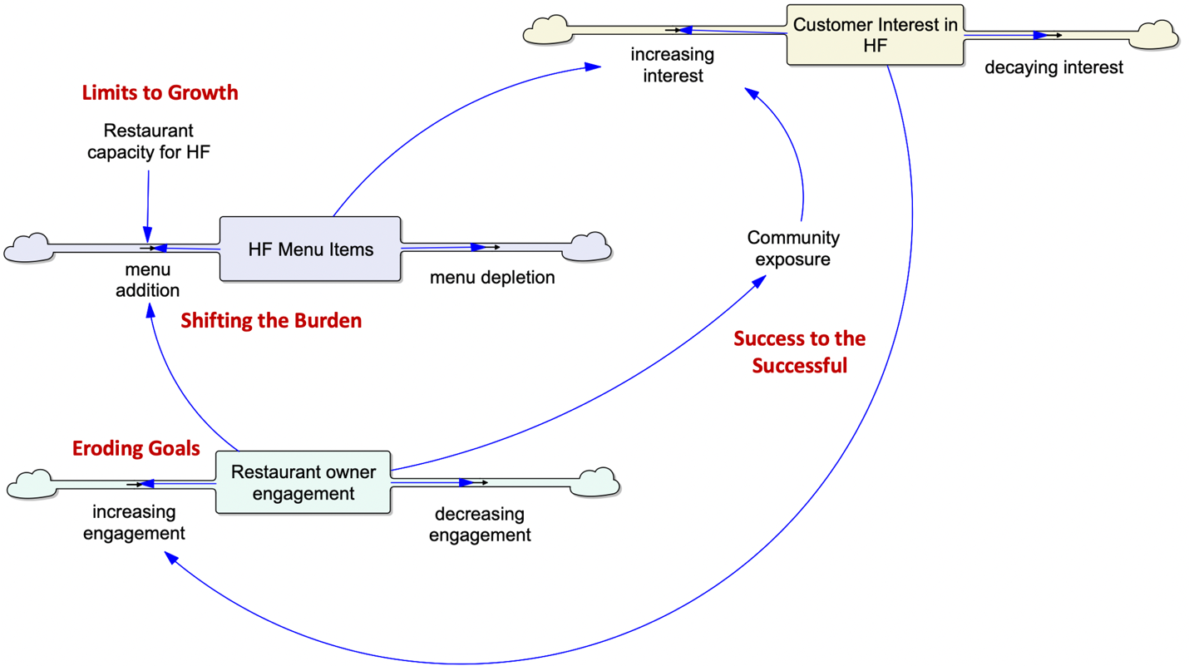
Figure S1. Stock-and-flow representation of the FRESH healthy restaurant intervention.
The model represents the implementation and sustainability dynamics of healthy food (HF) adoption in restaurants using three principal stocks: restaurant owner engagement, HF menu items offered by restaurants, and customer interest in healthy foods. Owner engagement increases the rate at which restaurants introduce HF menu items (menu addition), while the presence of HF offerings increases customer interest through both direct exposure to menu items and indirect exposure through community engagement and promotion. Customer interest can in turn reinforce restaurant owner engagement through demand signals, forming the primary reinforcing feedback loop linking restaurant adoption and customer demand. While an intervention team drives many of the positive flows into the stocks, as described in the abstract, there are several balancing processes that counteract the reinforcing loop, including engagement decay, menu depletion due to operational constraints, and declining customer sales and interest.
Several pathways and components in the stock-and-flow diagram correspond to classic system archetypes. Limits to Growth arises when reinforcing growth in HF adoption is constrained by restaurant capacity. Shifting the Burden reflects the intervention’s emphasis on strengthening restaurant capacity for offering HF rather than relying primarily on short-term demand incentives. Eroding Goals appears as a gradual decline in engagement and is mitigated through regular visits by interventionalists and continued technical assistance. Success to the Successful arises when increased visibility of HF adoption among restaurants through social media promotion, community engagement, and dashboards encourages further adoption.
The reinforcing pathway linking restaurant adoption and customer demand represents the mechanism through which the intervention can transition from implementation-driven change to self-sustaining healthy food adoption.
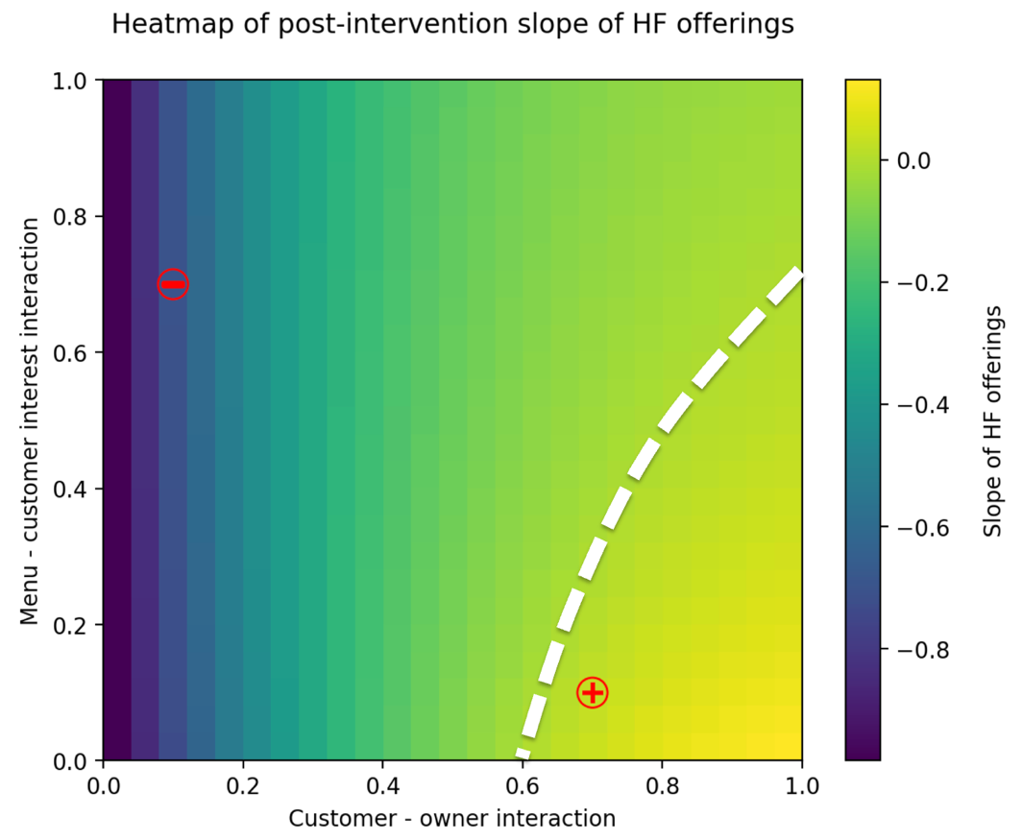
Figure S2. Tipping behavior in the sustainability phase of the FRESH intervention model.
The heatmap shows the trends of HF menu adoption with respect to two key parameters: the responsiveness of restaurant owners to customer demand signals (Customer – owner interaction) and the responsiveness of customers to HF menu offerings (Menu – customer interest interaction). Each point represents the slope of HF menu adoption during the sustainability (post-intervention) phase.
Regions with positive HF slope: For every point in this region, the number of HF menu items increases after the end of the intervention. Hence, these points correspond to a self-sustaining adoption regime
Regions with negative HF slope: For every point in this region, the number of HF menu items decline after the end of the intervention. Hence, these points correspond to reduced adoption.
Boundary between positive and negative HF slope: The points along the dashed line correspond to tipping points that separate these regions. This is where reinforcing feedback between restaurants and customers becomes sufficiently strong to overcome balancing processes such as engagement decay, menu depletion, and declining customer attention.
The red (-) and (+) markers indicate parameter combinations corresponding to decaying and sustaining HF menu offerings, respectively. The corresponding system trajectories are shown in Figure S3.
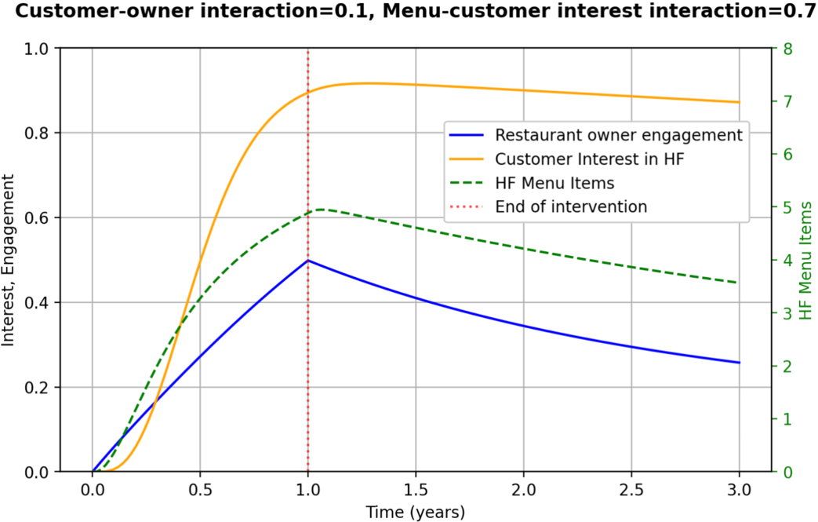

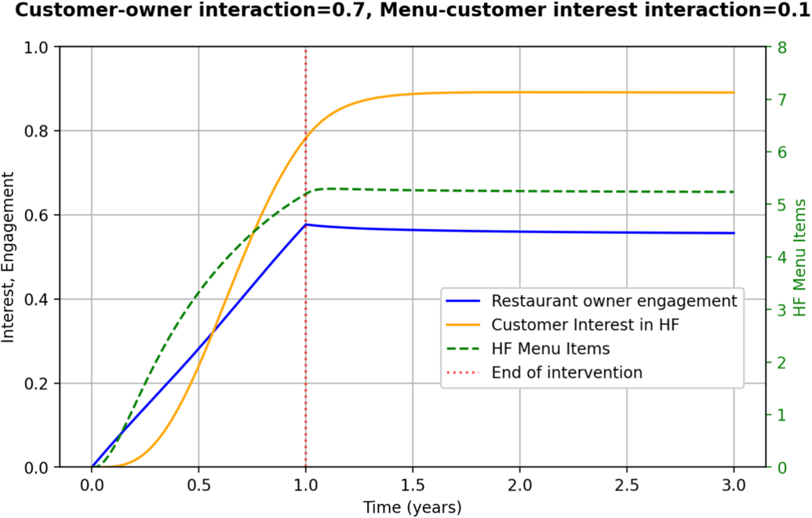
Figure S3. System behavior during the implementation and post-intervention phases.
Time trajectories of restaurant owner engagement, customer interest in HF, and the number of HF menu items (left axis) under parameter settings shown at the top of each plot.
Top plot illustrating decaying intervention effects: During the implementation phase, intervention activities increase restaurant engagement and HF offerings. After the intervention ends, the system gradually returns toward its pre-intervention equilibrium with decreasing number of HF offerings.
Bottom plot illustrating sustained intervention effects: By increasing the responsiveness of restaurant owners to customer interest (C customer owner = 0.7) HF offerings are sustained post-intervention. It is noted that sustainment is predicted even while the responsiveness of customers to HF menu offerings was reduced (C menu interest = 0.1), highlighting the importance of the lower segment of the reinforcing feedback loop between customers and restaurant owners in Figure S1.

